Natural Language Processing
MINI-PROJECT REPORT

ON

LexPopuli

BY

- A711 Amey Chougule
- A760 Muddasir Ansari
- A765 Manasi Aroskar
- A766 Khushi Gedam

Under the guidance of

Internal Guide
Prof. Suresh Mestry


Juhu-Versova Link Road Versova, Andheri(W), Mumbai-53
Department of Computer Engineering
University of Mumbai

Oct- 2025

Declaration

We wish to state that the work embodied in this project titled
“LexPopuli” forms our own contribution to the work carried out under the guidance of “Prof. Suresh Mestry” at the Rajiv Gandhi Institute of Technology.
I declare that this written submission represents my ideas in my own words and where others' ideas or words have been included, I have adequately cited and referenced the original sources. I also declare that I have adhered to all principles of academic honesty and integrity and have not misrepresented or fabricated or falsified any idea/data/fact/source in my submission. I understand that any violation of the above will be cause for disciplinary action by the Institute and can also evoke penal action from the sources which have thus not been properly cited or from whom proper permission has not been taken when needed.

(Students Signatures)
- A711 Amey chougule
- A760 Muddasir Ansari
- A765 Manasi Aroskar
- A766 Khushi Gedam

Abstract

LexPopuli is an AI-powered platform designed to simplify and democratize access to legal knowledge. Utilizing advanced Natural Language Processing (NLP) and Machine Learning (ML), it translates and summarizes complex legal documents into clear, easy-to-understand, and multilingual formats. The platform features an interactive legal Q&A module, a simplified legal question bank, and integrated user feedback through surveys to identify areas where people struggle most. LexPopuli breaks down barriers of language and complexity, empowering users with accurate legal understanding without needing formal legal training. Scalable by design, the platform is built to adapt to global legal systems, aiming to become a go-to resource for legal clarity across borders.
Initially focused on the Indian legal framework, LexPopuli is designed for global scalability, adaptable to various jurisdictions and legal systems across the world.

Contents

Sr. No. | Contents | Pg. No.
1 | Introduction
1 | 1.1 Introduction Description...………………………………………….. | 1
1 | 1.2 Ambiguity in Project…………. ……………………………………. | 1
2 | Proposed System  2.1 Proposed Statement………………………………………………  2.2 Design Details……………………………………………………  Architecture / Flow Diagram…………………………………….  2.3 Text Pre-Processing Steps……………………………………….  2.4 Model Processing Steps…………………………………………  2.5 Software and Hardware Requirements…………………………..  2.6 Dataset Used…………………………………………………….
3 | Results  3.1 Results……………………………………………………………….
4 | Conclusion
 | References

CHAPTER 1
Introduction

Introduction Description

LexPopuli is an AI-powered platform developed to simplify and democratize access to legal knowledge. The system leverages Natural Language Processing (NLP) and Machine Learning (ML) to translate, summarize, and explain complex legal documents in clear, easy-to-understand, and multilingual formats.
The platform helps individuals understand their rights, duties, and the laws governing them — without needing deep legal expertise. It features an AI-powered legal Q&A chatbot, a simplified legal question bank, and survey integration to collect user feedback and identify areas where people face difficulties in understanding legal terms.
The backend of LexPopuli efficiently manages the storage and processing of large legal datasets, while the frontend offers an intuitive interface for users to access and interact with legal information. The system integrates translation and summarization models using state-of-the-art language models (such as BERT, GPT, and RAG), ensuring accuracy and context preservation across different languages.
Initially designed around the Indian legal framework, LexPopuli is scalable and adaptable to various global jurisdictions. By bridging the gap between complex legal systems and the general public, it contributes to a more legally informed society, enabling citizens to confidently navigate legal matters and make informed decisions.

1.2 Ambiguity in Project
The LexPopuli project presents several ambiguities related to its data, models, and implementation. The data source is unclear, including how legal documents are collected, verified, and standardized. Language and translation ambiguities arise due to the difficulty of accurately translating legal terms across multiple languages without losing meaning. The summarization process may oversimplify complex legal concepts, raising concerns about accuracy and interpretation. Ambiguity also exists in how models like BERT, GPT, and RAG are integrated and evaluated for performance. Additionally, user interaction boundaries are not clearly defined — it is uncertain whether the chatbot provides legal advice or just explanations. Ethical and privacy concerns regarding user data and platform liability further add to the uncertainty. Finally, scalability and adaptability across different jurisdictions remain ambiguous, highlighting the need for clearer definitions and structured governance in the system’s design.

CHAPTER 2
Proposed System

2.1 Proposed Statement

LexPopuli aims to simplify legal knowledge by breaking down complex legal documents into user-friendly explanations. The system is designed to handle multilingual inputs (Hindi, Marathi, English) and output simplified, translated, and summarized content for users. During analysis, we identified the following needs:
- Legal Document Simplification – reduce complexity while maintaining accuracy.
- Summarization & Concept Explanation – short, easy-to-understand outputs.
- Translation Framework – multilingual support using APIs.User
- Accessibility – secure access via frontend and backend integration.
- Interactive Features – quizzes, legal Q&A chatbot, and law data explorer.
2.2 Design Details
Architecture / Flow Diagram

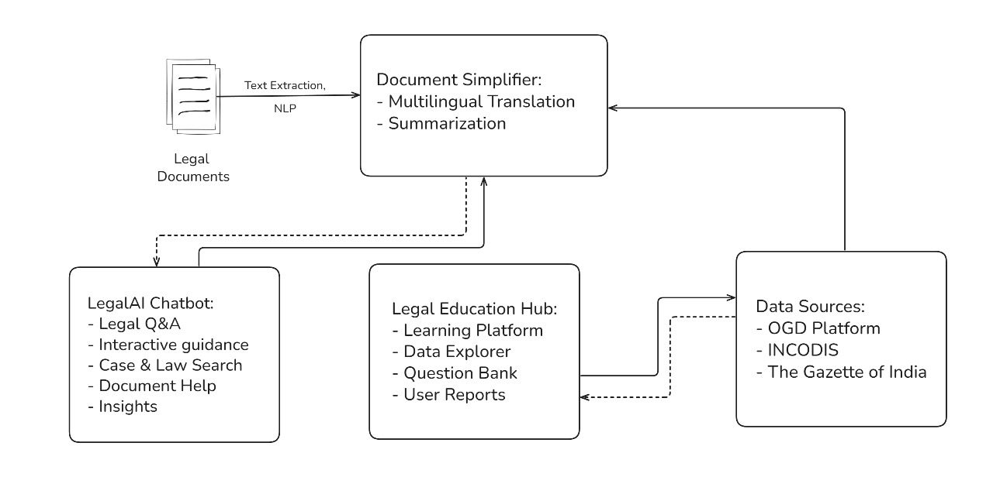

2.3 Text Pre-Processing Steps

The text pre-processing steps aim to clean and structure the legal documents for further NLP tasks such as translation, summarization, tagging, and classification.

Tokenization: Break legal documents into individual tokens (words, phrases, or symbols). Handles multilingual text using appropriate language tokenizers. Maintain sentence structure for accurate summarization.

Stop Words Removal: Remove common and irrelevant words (e.g., “the”, “is”, “and”) to reduce noise. Use a legal domain–specific stop words list to preserve meaningful terms. Normalize text by converting to lowercase before removal.

Text Normalization and Cleaning: Remove punctuation, special symbols, and unnecessary white spaces. Standardize legal references (e.g., Section numbers, Acts, Clauses). Handle multilingual characters for consistent processing.

Lemmatization / Stemming: Convert words to their root form for uniform analysis. Useful for legal phrase grouping and concept extraction.

Named Entity Recognition (NER) (optional pre-step): Extract legal entities like case names, court names, and legal acts to support downstream tasks.

2.4 Model Processing Steps:

After pre-processing, the text is passed through the NLP pipeline for advanced tasks like translation, summarization, and tagging.

Step 1: Text Extraction: Extract relevant content from legal documents using OCR/NLP parsing.

Step 2: Text Simplification:Use multilingual translation and legal text simplification models to make documents easier to understand.

Step 3: Summarization: Generate concise summaries highlighting key legal points and judgments.

Step 4: Tagging and Classification: Tag legal terms, identify legal sections, and classify documents into categories (e.g., case laws, statutes, judgments).

Step 5: Integration with Modules

Feed processed data to:

LegalAI Chatbot (for Q&A and guidance)

Legal Education Hub (for data exploration and learning)

Data Sources like OGD Platform, INCODIS, Gazette of India.

CHAPTER 3

3.1 Results
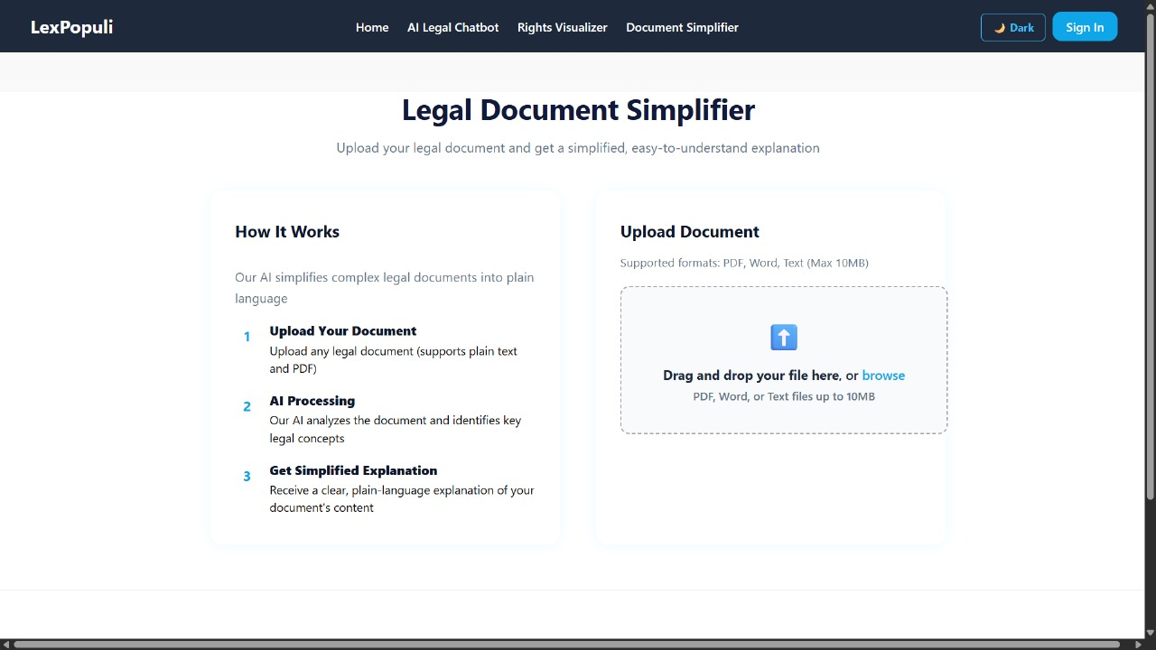

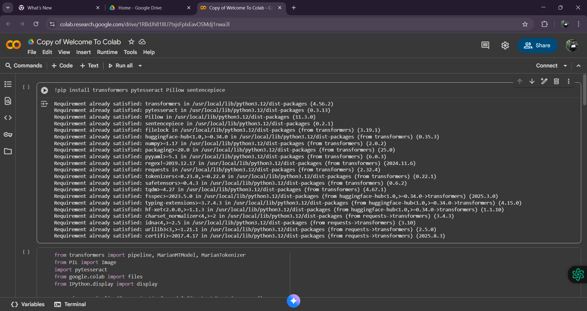

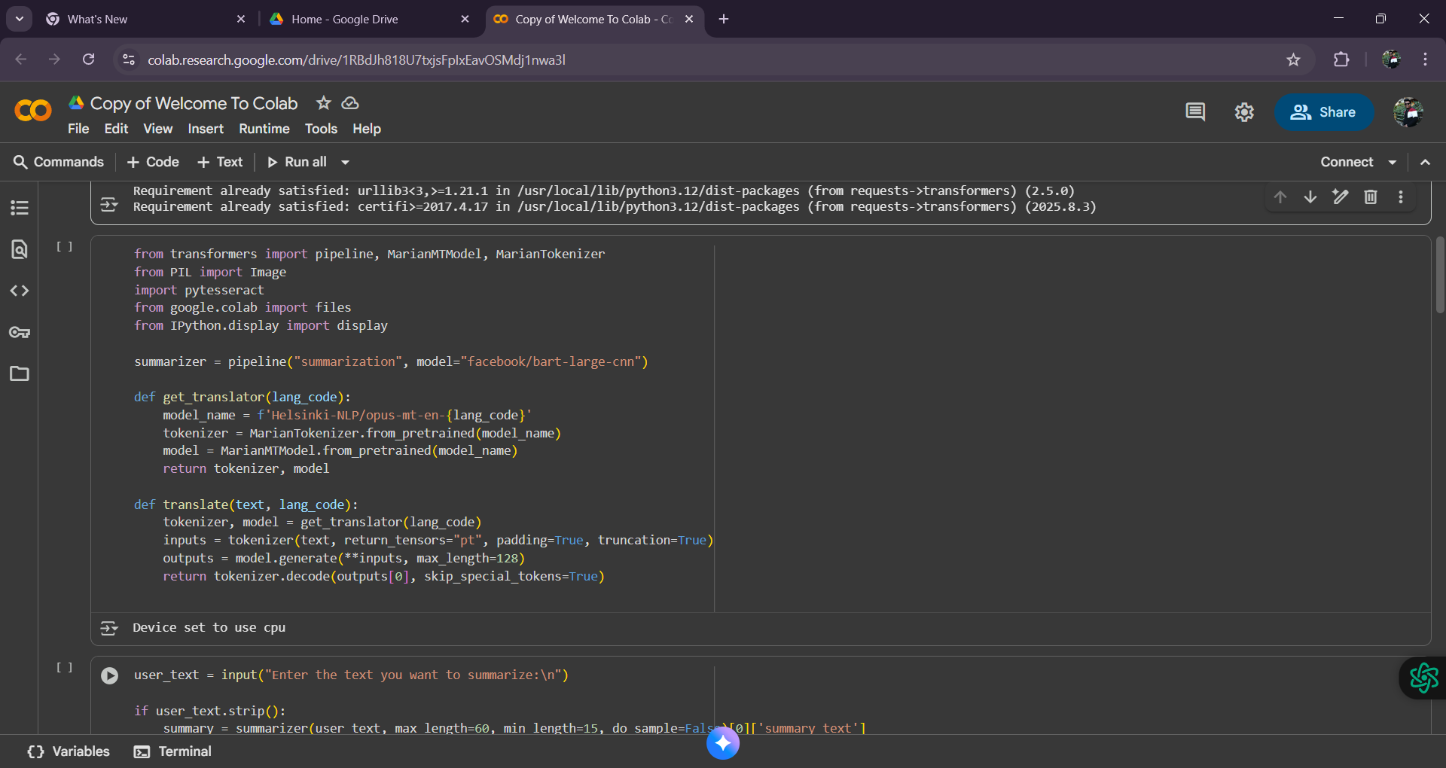

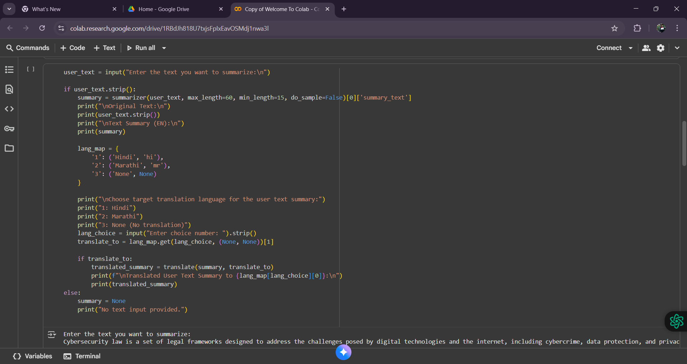

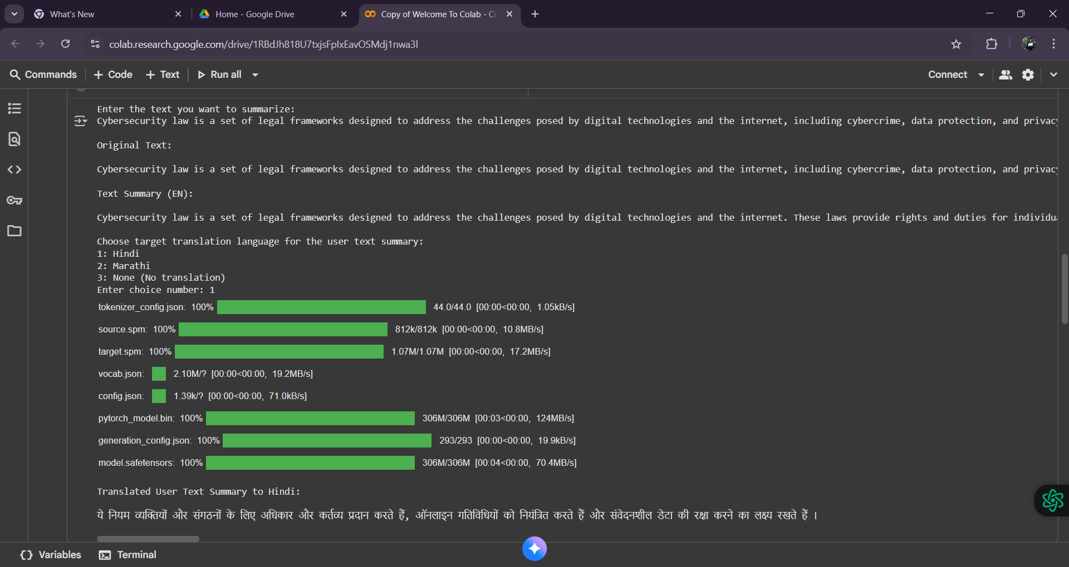

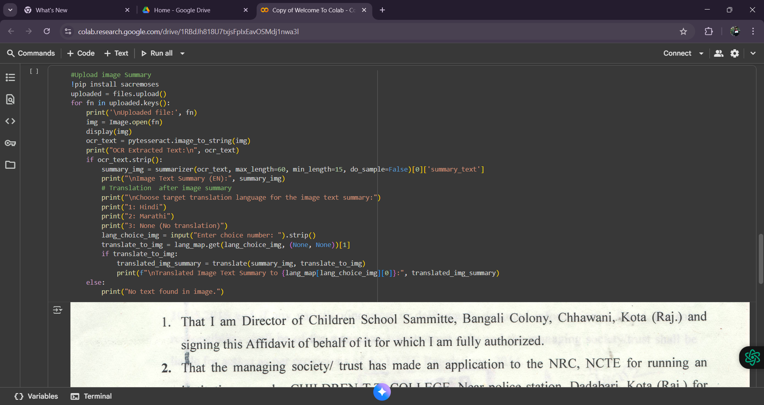

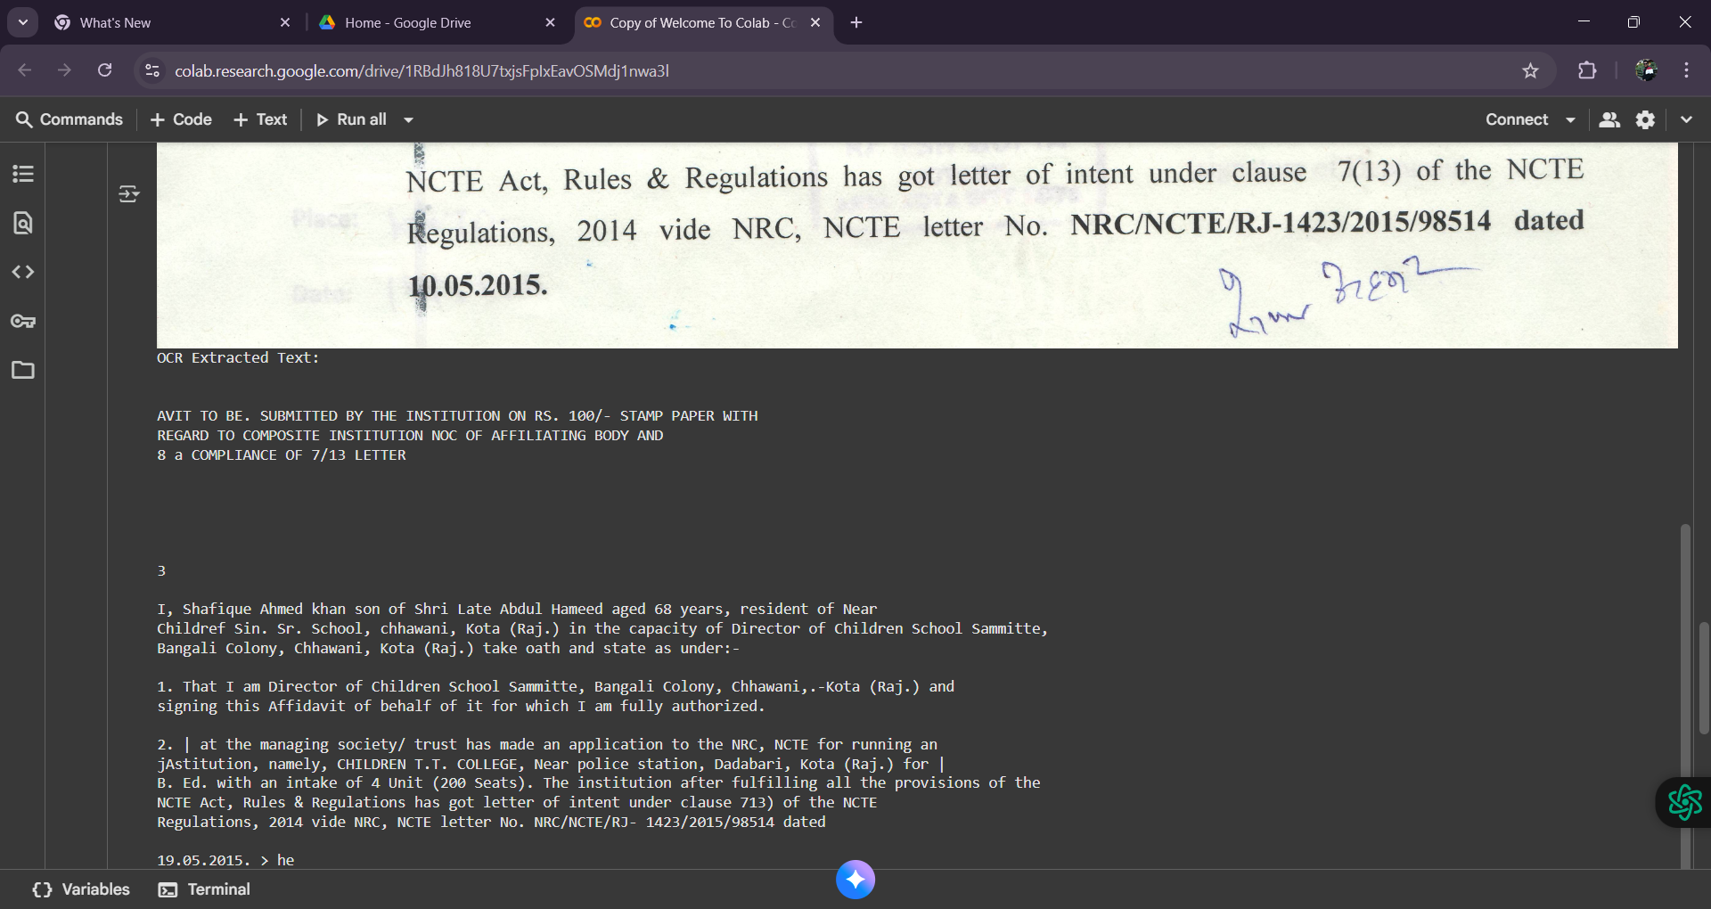

CHAPTER 4
Conclusion and future work

LexPopuli represents a significant advancement in making legal knowledge accessible, understandable, and inclusive for all. By integrating Artificial Intelligence, Natural Language Processing, and multilingual translation, the platform simplifies complex legal information into user-friendly content. It empowers individuals to comprehend their rights, responsibilities, and the laws that affect their daily lives—without requiring legal expertise. Beyond being a technological innovation, LexPopuli is a step toward social empowerment, fostering legal awareness and bridging the gap between citizens and the justice system. Ultimately, it contributes to building a more informed, confident, and legally literate society.

REFERENCES

- Alessandro Armando, Gabriele Costa, Alessio Merlo, Bring Your Own Device, Securely, Proceedings of the 28th Annual ACM Symposium on Applied Computing, ACM New York, NY, USA , pp. 1852-1858 March 2013.

- R ebecca Copeland, Noel Crespi, Analyzing Consumerization - Should Enterprise Business Context Determine Session Policy?, 2012 IEEEProceedings of 16th International Conference on Intelligence in Next Generation Networks (ICIN), pp.187-193 ,2012.

Prathamesh Kalamkar, Janani Venugopalan, Vivek Raghavan, 2023, Benchmarks for Indian Legal NLP

Mingruo Yuan1 , Ben Kao1 , Tien-Hsuan Wu1, et al, 2023, Bringing Legal Knowledge to the Public by Constructing a Legal Question Bank Using Large-scale Pre-trained Language Model

